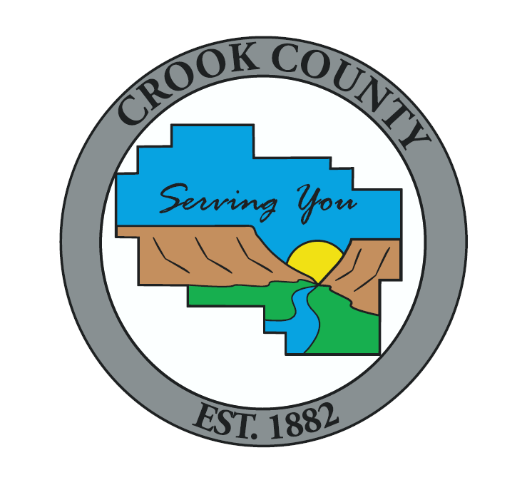

**Crook County Planning Commission**

**Agenda**

**February 12th, 2020 at 6:00 PM**

320 NE Court St, Prineville, OR

Notice is hereby given that the Crook County Planning Commission will hold a Public Meeting.

**Pledge Of Allegiance**

**Approve Minutes**

* December 11, 2019
* January 8, 2020

**Public Hearing**

* **Continuation from January 29th for Deliberations Only - Modification – Destination Resort Development** **Plan Remington Ranch Destination Resort (Full Health, LLC applicant/owner) – Record number 217-19-000675-PLNG -** is requesting modification of the destination resort development plan approved by the Crook County Planning Commission in 2007 (CU-DES-002-06). The specific request is to modify the development plan to reduce the number of dwelling units and overnight lodging units, to modify the types of recreational activities at the site and to reflect the new owner’s vision to create a resort experience with a range of health, wellness, spa services and recreational amenities in a low-key and natural environment. The Applicant has provided an updated Transportation Impact Analysis to reflect the proposed development and changes in traffic and infrastructure in the vicinity. The proposed modification will be reviewed subject to the requirements of Crook County Code 18.116 (Destination Resort Overlay), 18.160 (Conditional Use) and 18.180 (Transportation Impact Analysis). The subject property is identified as Township 14 South, Range 14 East Willamette Meridian, Sections 33 and 34, Tax lots 1800 and 1802 and Township 15 South, Range 14 East Willamette Meridian, Sections 3, 4, 5, 9 and 10, Tax lots 201, 203, 204, 205, 206, 207, 208, 209, 210, and 211.

**Other Business**

* Community Development Department Updates
  + Work Plan for 2020
  + Overview of 2019
  + Planning Commission Elections and Commission Term Updates

**Other Information**  
Public hearing agendas, staff reports, and applications are available at Crook County Community Development, 300 NE Third St., Room 12, Prineville, Oregon, or via e-mail at [plan@co.crook.or.us](mailto:plan@co.crook.or.us).

**If you have any questions please feel free to contact Crook County Planning at (541) 447-3211 Ext. 1 (Planning).**