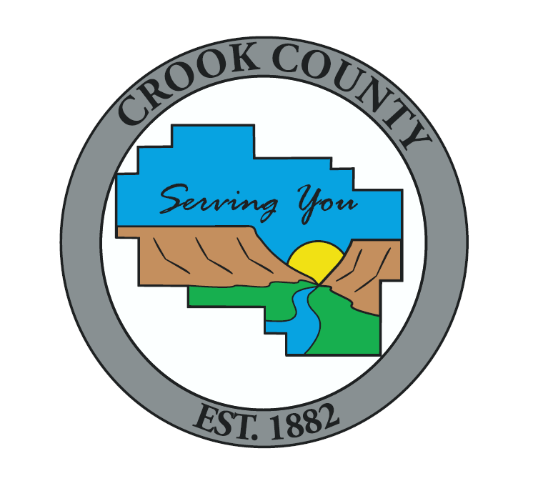

**Crook County Planning Commission**

**Agenda**

**January 15th, 2020 at 6:00 PM**

320 NE Court St, Prineville, OR

Notice is hereby given that the Crook County Planning Commission will hold a Public Meeting.

**Pledge Of Allegiance**

**Public Hearing**

* **Continuation for Deliberations only - Conditional Use – Commercial Activity in Conjunction with Farm Use (Processing Facility) - Stanley Shephard (owner) and Central Oregon Processing LLC, Successor to Evergreen State Holdings, LLC (applicant) – Record number 217-19-000987-PLNG** - is requesting a conditional use permit to construct and operate a commercial outdoor processing facility in conjunction with farm use. Commercial Activities including the processing of farm crops are allowed as conditional uses under Crook County Code 18.16 (EFU-3 (Powell Butte Area), 18.180.010 (Transportation Impact Analysis), and 18.160 (Conditional Uses). The property is identified as Township 14 S, Range 14 E WM, tax lot 1400.

**Other Business**

* Community Development Department Updates

**Other Information**  
Public hearing agendas, staff reports, and applications are available at Crook County Community Development, 300 NE Third St., Room 12, Prineville, Oregon, or via e-mail at [plan@co.crook.or.us](mailto:plan@co.crook.or.us).

**If you have any questions please feel free to contact Crook County Planning at (541) 447-3211 Ext. 1 (Planning).**